Grade:

Course Code/Title:

Section Number:

Instructor Name :

Semester/Year:

LAB REPORT TITLE:
EXPERIMENT1 - LINEAR HEAT CONDUCTION
Student Name(s) | Student Number | Student Signature

Please list any others who contributed to this lab report:

_____________________________________

Student declaration:
By signing above, I attest that I wrote this assignment\lab report alone or with the help of the students I have listed above. I understand that any act of plagiarism will be treated as academic misconduct for which provisions stipulated in the Student Code of Conduct should apply.

Table of Contents
Introduction 5
Theory 6
Procedure 7
A). Steady State Heat Conduction 7
Procedure 9
Results and Discussion 11
Calculations 12
Sources of Error 15
1. Conclusion 16
References 17

Abstract
The purpose of this experiment is to get a better understanding of a component that may have an influence on the linear conduction heat transfer process. According to the findings of this study, linear heat transport is governed by Fourier's law.. Due to the fact that various materials have varied conductivities and cross-sectional areas, the flux rates will also vary depending on the material used. Brass transmits heat more efficiently than stainless steel, although paper does not carry any heat. Between the contact surfaces of the test component and the cooler area, there is a significant temperature difference between them.

Introduction
Thermal conduction occurs when there is a temperature difference inside a material, allowing heat energy to be transmitted between the two areas of difference. When this happens, practically everything goes the opposite way. The fact that convective heat transfer occurs in both liquids and gases makes it difficult to measure just pure conduction. Real heat conduction occurs in three dimensions, making it difficult to define and quantify without a lot of processing power. To establish the basic rule connecting the rate of heat flow to a temperature gradient and an area, studies employing a one-dimensional technique are necessary.
To demonstrate linear energy transmission through a uniform plane wall based on temperature distribution, this experiment was designed and carried out successfully. To demonstrate heat transfer and dispersion, this experiment varied the temperature distribution over the surface. You may be able to tell how effectively a metal specimen conducts heat based on the amount of k (the proportionality constant) it contains (good conductor).
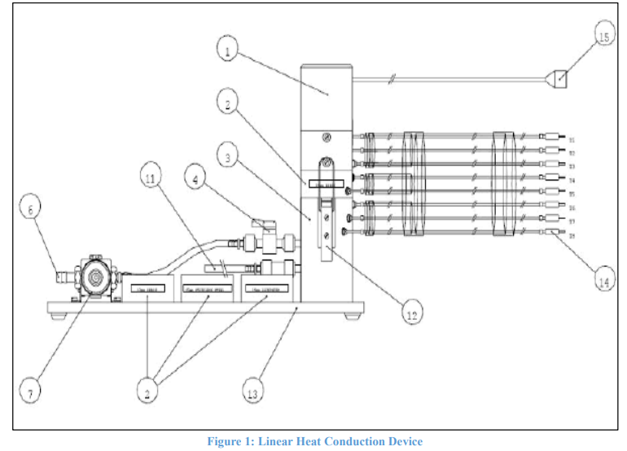
Figure 1 linear Heat Conduction Devise

Theory
Hotness travels through the climate in three fundamental ways: conduction, convection, and radiation. In this examination, you will show heat move by conduction in a shut framework. Conduction might happen in an assortment of media, including gases, fluids, and solids. Conduction happens in solids because of sub-atomic vibrations, and it happens in gases and fluids because of impacts and dispersion. As a general rule, the rate at which hotness is communicated depends on the math of the medium, the thickness of the material used, and the temperature differential across the medium. Utilizing Fourier's standard of hotness conduction, it is feasible to register the measure of hotness that is moved in an assortment of designing applications: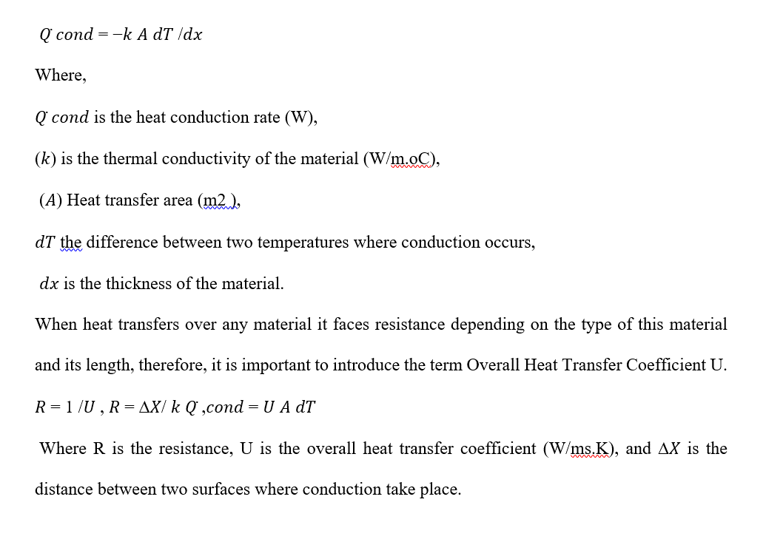

Procedure

A). Steady State Heat Conduction
Procedure
Start the experiment only when instructor gives tgo-ahead and gives you safety guidelines.
Make sure there is enough water in the cold storage area of the refrigerator.
When putting in flexible water connections, keep drainage systems in mind.
Verify that each thermocouple is correctly connected to its socket in the service unit (K).
Set the manual setting on the service unit's switch by pressing the Manual button. The number four is an example of this (B).
Make sure the measurement selection switch is set to V before doing any measurements. (E) Turn on the main panel's standby switch (A)
Verify the voltage readings on your panel meter all the time to ensure they are correct (since you selected V on step number 6).
Work your way up from 0V to 12V starting with a source of power.
For the time being, set the temperature switch (G) to T1. After that, you'll be moving it.
You may use a different temperature reading by flicking a switch (G). T1 has been selected as the new value.
Watch the next panel meter's temperature for the next 10 minutes (J).
Changing the temperature switch at this point will display further measurements. T1 should then be measured. Use the right units of measurement while answering questions 14 and 15.
Fill the table with the positions of each sensor along the brass rod in issue, assuming the interval between thermocouples is 0.015m.

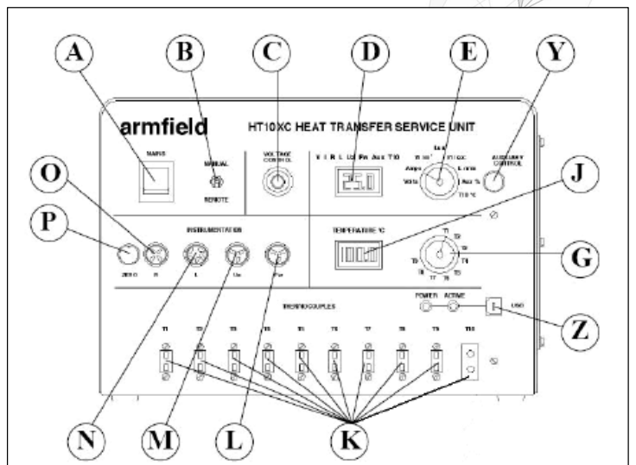
Figure 2 HT10XC Service Unit
We used the Fourier Rate Equation and two different junction specimens to evaluate the heat conductivity of brass and stainless steel in this research.

Procedure
Figure 3 depicts the temperature distribution throughout the cylindrical bar; determine the thermal conductivity of the brass specimen by following the techniques outlined in the next section.
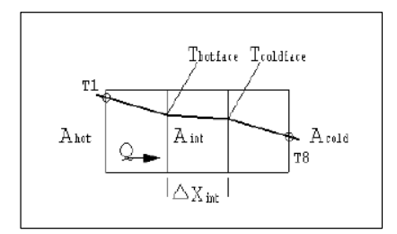
Figure 3 Diagram showing heat transfer through the brass intermediate section

When doing electrical work, use the equation Q = V I to determine the rate at which heat is transferred to the brass bar. Assume that nearly little heat is lost throughout the transfer process.
Slide the switch E on panel D to the appropriate position to read the voltage and current inputs.
Take measurements of the intermediate segment (Xint) in steps 3 and 4 using a vernier caliper.
Using a vernier caliper, figure out the diameter D of the brass that will be used in the project's intermediate phase.
Calculate the cross-sectional area of the brass rod using the formula Aint = Dint 2. This value represents the surface area of the heated and cold walls, respectively.
Step 6: Using the graph that was created, figure out the temperatures of the hot and cold wall surfaces.
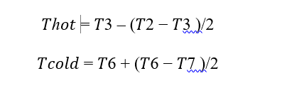

Results and Discussion

Exercise A
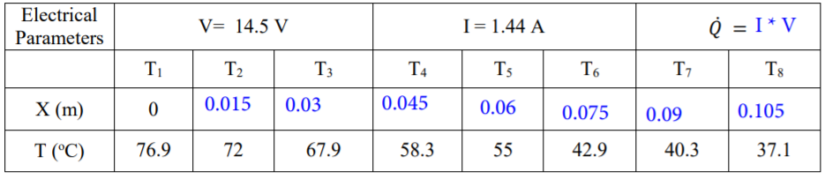
Figure 4 results of exercise one, data table

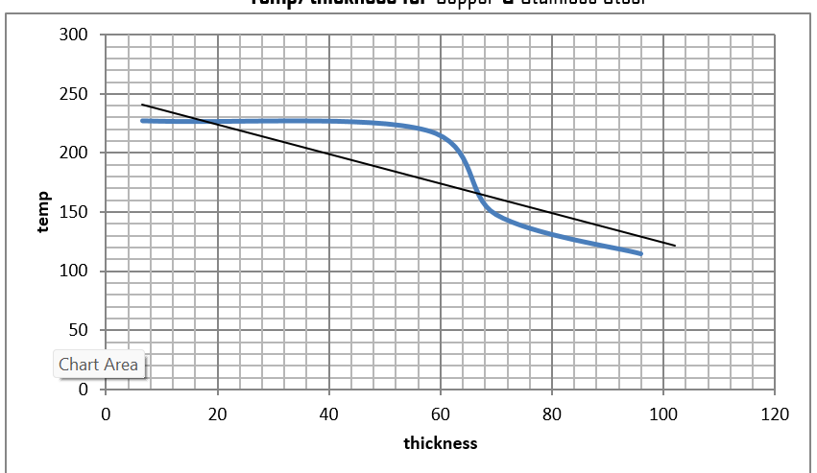
Figure 5 Thermal conductivity is a property of materials that determines how quickly heat passes through them.

Calculations

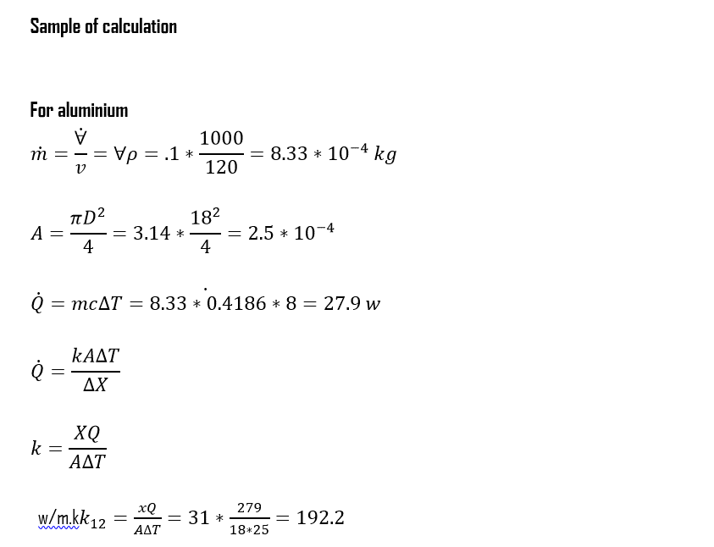
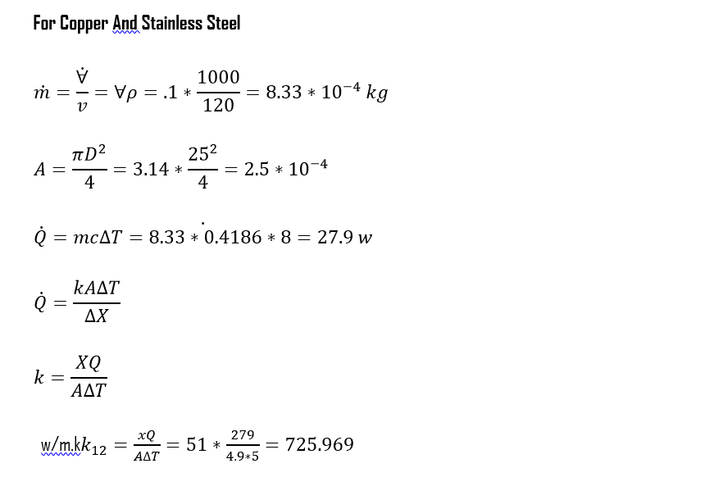
Exercise B
Thermal conduction of brass
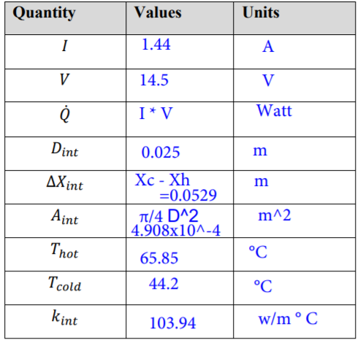
Theoretical value of brass is 109
And the measured value of thermal conductivity of brass is 103
So the percentage error is given by
(109-103)/109 = the error is 5.5%

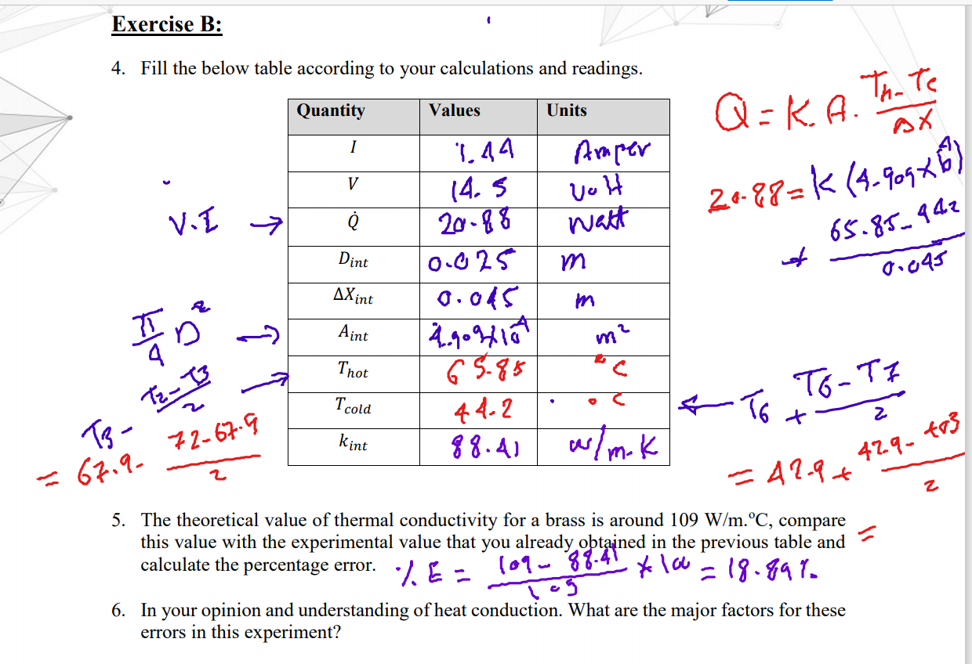

Sources of Error

Error reasons linked to the loss of steady state circumstances are listed in Table 1. Problems arising when instruments deviate from steady state are wholly dependent on the instrument in issue. Temperature fluctuations and non-linear heat transfer are only a few instances of the model's flaws.
Q/A has been linked to two different kinds of mistake sources.
High-frequency magnetic field instruments employ thin heat flux sensors, one in each instrument platen, to measure Q/A. A detailed analysis of the heat flux sensor designs for this instrument is impossible owing to intellectual property restrictions.
Mistakes may fall into one of three categories. As with the first kind of mistake, it is completely caused by the specimen and hence completely under the control of the operator. Because the second kind of error is not tied in any way to the specimen, it is completely in the hands of the operator. A specimen's x value's mean and standard deviation are easily calculated; the trickier part is determining the standard deviation around the specimen's mean values. Tolerance for specimen preparation tolerance may be defined as the degree of inaccuracy that can be tolerated in a specimen. Inaccuracy might be shown as undulations or hollows or a lack of parallelism. According to Section 4, the measurement of T is prone to a variety of errors, most of which are linked to the Kind E thermocouples employed by the instrument under investigation to measure T1 and T2 (where the value of T is equal to the difference between the values of T1 and T2).

Conclusion

Thermal conductivity of materials vary based on numerous parameters, such as the quantity of heat present, the amount of accessible surface, and so on. This is well-known. Due to the fact that temperature and distance are created of the same material, it's easy to observe that they are inversely proportional. The relationship between copper and Style Steel samples, for example, is not linear when compared to the others. Due to the significant gap in similarities, the spectrum is non-linear as it comprises two articles with varying conductivities. Because of this, copper is a powerful heat conductor, but Style Steel is lower than even copper in terms of conductivity.

References
A flat-plate thermal-conductivity apparatus for measuring low-conductivity materials at cryogenic temperatures. (n.d.). Thermal Conductivity Measurements of Insulating Materials at Cryogenic Temperatures, 3-3-10. https://doi.org/10.1520/stp47215s
Smontara, A., Biljaković, K., Bilušić, A., Pajić, D., Starešinić, D., Lévy, F., & Berger, H. (2021). Thermal conductivity of linear chain semiconductor (NbSe4)3I. Thermal Conductivity 23, 266-276. https://doi.org/10.1201/9781003210719-29
Smontara, A., Biljaković, K., Bilušić, A., Pajić, D., Starešinić, D., Lévy, F., & Berger, H. (2021). Thermal conductivity of linear chain semiconductor (NbSe4)3I. Thermal Conductivity 23, 266-276. https://doi.org/10.1201/9781003210719-29

